Use Cases Description
UC6- Borrower Management

For

Meeting Room
Booking System
(MRBS)

Prepared by K15T1-Team11
Van Lang University
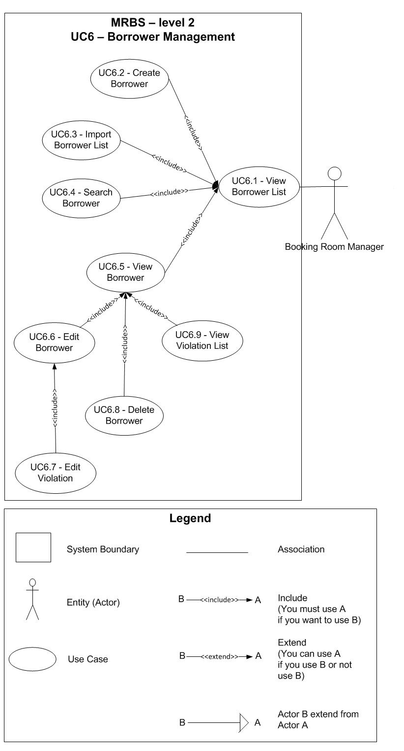
Table of Contents
UC6.1 – View Borrower List 4
UC6.2 – Create Borrower 5
UC6.3 – Import Borrower List 6
UC6.4 – Search Borrower 7
UC6.5 – View Borrower 8
UC6.6 – Edit Borrower 9
UC6.7 – Edit Violation 10
UC6.8 – Delete Borrower 11
UC6.9 – View Violation List 11

UC6.1 – View Borrower List
ID | UC6.1
Name | View Borrower List
Author | Son Dang | Modify by | Tam Do
Date | 06/18/12 | Update | 06/29/12
Actor | Booking Room Manager
Description | User can view a list of borrower
Precondition | User signed in system by Booking Room Manager’s account
Post condition: | System shows all borrower
Main flow: | 1. User press “Danh mục”  2. User choose “Quản lý người mượn”  3. System show new dialog “Quản lý người mượn”  4. System show a list of borrower  5. System load a list of group borrower in database into combobox “Tên nhóm” (one at search area, one at borrower information area)
Alternative flow:
Exception :
Includes:
Priority: | Normal
Business rules:
Mockup screen

UC6.2 – Create Borrower
ID | UC6.2
Name | Create Borrower
Author | Son Dang | Modify by | Tam Do
Date | 06/18/12 | Update | 06/29/12
Actor | Booking Room Manager
Description | User can create a new borrower
Precondition | User signed in system by Booking Room Manager’s account  User staying at “Quản lý người mượn” form
Post condition: | System create a new borrower into database and show announcement
Main flow: | 1. User press “Thêm” button  2. System change form to create a new borrower  3. User fill in the form  4. User press “Lưu” button  5. System check the valid of information (BR6.2.01, BR6.2.02, BR6.2.03, BR6.2.04)  6. System check the valid of information with existing data in database (BR6.2.05, BR6.2.06)  7. System save a new room in database  8. System show announcement that “Thêm người mượn thành công” with “OK” button
Alternative flow: | After step 3 of main flow:  4. User press “Hủy” button  5. System change form to not create a new borrower
Alternative flow: | After step 5 of main flow (BR6.2.01):  6. System show announcement that “Các thông tin có (*) không được để trống” with “OK” button
Alternative flow: | After step 5 of main flow (BR6.2.02, BR6.2.03, BR6.2.04)  6. System show announcement that “Thông tin nhập vào không hợp lệ” with “OK” button
Alternative flow: | After step 6 of main flow (BR6.2.05):  7. System show announcement that “Mã người mượn đã tồn tại trong hệ thống, vui lòng thử lại” with “OK” button
Alternative flow: | After step 6 of main flow (BR6.2.06):  7. System show announcement that “Email đã tồn tại trong hệ thống, vui lòng thử lại” with “OK” button
Exception :
Includes:
Priority: | High
Business rules: | BR6.2.01 – Required field not accept null: “Tên nhóm”; “Mã người mượn”; “Họ tên”;“Email”  BR6.2.02 – “Mã người mượn” not accept more than 20 characters and space between them; accept characters and numeric only  BR6.2.03 – “Họ tên” not accept more than 50 characters; accept characters and numeric, can use Vietnamese language  BR6.2.04 – “Email” not accept more than 25 characters and space between them; must follow standard of email address (ex: @abc.xyz)  BR6.2.05 – “Mã người mượn” not exist in database  BR6.2.06 – “Email” not exist in database
Mockup screen

UC6.3 – Import Borrower List
ID | UC6.3
Name | Import Borrower List
Author | Son Dang | Modify by | Tam Do
Date | 06/18/12 | Update | 06/29/12
Actor | Booking Room Manager
Description | User can import a borrower list into system by excel file (*.xls, *.xlsx)
Precondition | User signed in system by Booking Room Manager’s account  User staying at “Quản lý người mượn” form
Post condition: | System import a borrower list into database
Main flow: | 1. User press “Nhập file” button  2. System show new dialog “Import danh sách người mượn” form  3. System load a list of group borrower in database into combobox “Tên nhóm”  4. User choose a group borrower for list of borrower want to import  5. User press “…” button  6. System show open file dialog  7. User choose excel file want to import  8. User press “Open” button  9. System show directory path of file excel  10. User press “Nhập file” button  11. System show new dialog waiting to check  12. System check template of file excel  13. System check all information of file excel:  13.1. System check the valid of information (BR6.3.01; BR6.3.02; BR6.3.03; BR6.3.04)  13.2. System check the valid of information with existing data in database (BR6.3.05; BR6.3.06)  13.3. System save/edit new information into database  14. System show all information of file into 3 list (list of create new borrower, list of edit borrower existed, list of error)  15. System turn off dialog waiting to check  16. User press “Đồng ý” button  17. System show announcement that “Danh sách người mượn đã được thêm vào hệ thống” with “OK” button
Alternative flow: | After step 7 of main flow:  8. User press “Cancel” button  9. System close open file dialog
Alternative flow: | After step 12 of main flow:  13. System show announcement that “Định dạng nội dung của file excel không hợp lệ” with “OK” button
Alternative flow: | After step 15 of main flow:  16. User press “Hủy” button  17. System clear all information of this import file in database  18. System clear all information of file in 3 list views (list of create new borrower, list of edit borrower existed, list of error)
Exception :
Includes:
Priority: | Very High
Business rules: | BR6.3.01 – Required field not accept null: “Tên nhóm”; “Mã người mượn”; “Họ tên”; “Email”  BR6.3.02 – “Mã người mượn” not accept more than 20 characters and space between them; accept characters and numeric only  BR6.3.03 – “Họ tên” not accept more than 50 characters; accept characters and numeric, can use Vietnamese language  BR6.3.04 – “Email” not accept more than 25 characters and space between them; must follow standard of email address (ex: @abc.xyz)  BR6.3.05 – “Mã người mượn” has existed in database  BR6.3.06 – “Email” has existed in database
Mockup screen

UC6.4 – Search Borrower
ID | UC6.4
Name | Search Borrower
Author | Son Dang | Modify by | Tam Do
Date | 06/18/12 | Update | 06/29/12
Actor | Booking Room Manager
Description | User can search borrower by name, code or group borrower or all borrower
Precondition | User signed in system by Booking Room Manager’s account  User staying at “Quản lý người mượn” form
Post condition: | System show the results
Main flow: | 1. User type the word to search for by code  2. User press “Enter” from keyboard  3. System check the valid of information (BR6.4.01)  4. System show the results
Alternative flow: | After step 3 of main flow (BR4.3.01):  4. Nothing appears on list of room
Alternative flow: | After step 4 of main flow:  5. User press “Tất cả” button  6. System show all room on list of room
Alternative flow: | 1. User type the word to search for by name  2. User press “Enter” from keyboard  3. System check the valid of information (BR6.4.01)  4. System show the results
Alternative flow: | 1. User choose a group borrower to search by group borrower  2. System show the results
Exception :
Includes:
Priority: | Normal
Business rules: | BR6.4.01 – “Tìm kiếm phòng” not accept more than 50 characters; accept characters and numeric, can use Vietnamese language
Mockup screen

UC6.5 – View Borrower
ID | UC6.5
Name | View Borrower
Author | Son Dang | Modify by | Tam Do
Date | 06/18/12 | Update | 06/29/12
Actor | Booking Room Manager
Description | User can view a detail borrower information
Precondition | User signed in system by Booking Room Manager’s account  User staying at “Quản lý phòng” form
Post condition: | System show a detail room information that user choose
Main flow: | 1. User choose a room from list of room  2. System show a detail room information that user choose
Alternative flow:
Exception :
Includes:
Priority: | Normal
Business rules:
Mockup screen

UC6.6 – Edit Borrower
ID | UC6.6
Name | Edit Borrower
Author | Son Dang | Modify by | Tam Do
Date | 06/18/12 | Update | 06/29/12
Actor | Booking Room Manager
Description | User can edit a borrower information
Precondition | User signed in system by Booking Room Manager’s account  User staying at “Quản lý người mượn” form and viewing a detail borrower information
Post condition: | System edit a borrower information in database and show announcement
Main flow: | 1. User edit whatever they want (BR6.6.01)  2. User press “Lưu” button  3. System check the valid of information (BR6.6.02; BR6.6.03; BR6.6.04)  4. System save a room information that edited in database (BR6.6.05)  5. System show announcement that “Chỉnh sửa thông tin thành công” with “OK” button
Alternative flow: | After step 1 of main flow:  2. User press “Hủy” button  3. System restore all information before user edit
Alternative flow: | After step 3 of main flow (BR6.6.02):  6. System show announcement that “Các thông tin có (*) không được để trống” with “OK” button
Alternative flow: | After step 3 of main flow (BR6.6.03; BR6.6.04):  4. System show announcement that “Thông tin nhập vào không hợp lệ” with “OK” button
Alternative flow: | After step 4 of main flow (BR6.6.05):  5. System show announcement that “Email đã tồn tại trong hệ thống, vui lòng thử lại” with “OK” button
Exception :
Includes:
Priority: | High
Business rules: | BR6.6.01 – User can edit field: “Tên nhóm”; “Mã người mượn”; “Họ tên”; “SDT”; “Email”  BR6.6.02 – Required field not accept null: “Tên nhóm”; “Mã người mượn”; “Họ tên”; “Email”  BR6.6.03 – “Họ tên” not accept more than 50 characters; accept characters and numeric, can use Vietnamese language  BR6.6.04 – “Email” not accept more than 25 characters and space between them; must follow standard of email address (ex: @abc.xyz)  BR6.6.05 – “Email” not exist in database (except old email)
Mockup screen

UC6.7 – Edit Violation
ID | UC6.7
Name | Edit Violation
Author | Tam Do | Modify by
Date | 06/29/12 | Update
Actor | Booking Room Manager
Description | User can remove violation of borrower that choose to view detail before
Precondition | User signed in system by Booking Room Manager’s account  User staying at “Quản lý phòng” form and viewing a detail room information
Post condition: | System remove violation that user check in database
Main flow: | 1. User choose violation that want to remove  2. User press “Lưu” button  3. System remove violation that user choose in database
Alternative flow: | After step 1 of main flow:  2. User press “Hủy” button  3. System restore all information before user edit
Exception :
Includes:
Priority: | Normal
Business rules:
Mockup screen

UC6.8 – Delete Borrower
ID | UC6.8
Name | Delete Borrower
Author | Son Dang | Modify by | Tam Do
Date | 06/18/12 | Update | 06/29/12
Actor | Booking Room Manager
Description | User can delete a borrower information
Precondition | User signed in system by Booking Room Manager’s account  User staying at “Quản lý người mượn” form and viewing a detail borrower information
Post condition: | System delete a borrower information in database and show announcement
Main flow: | 1. User press “Xóa” button  2. System show announcement that “Bạn có muốn xóa thông tin này khỏi hệ thống không?” with “Yes” and “No” button  3. User press “Yes” button  4. System delete a borrower information in database (BR6.8.01)
Alternative flow:
Exception :
Includes:
Priority: | Normal
Business rules: | BR6.8.01 – Not delete information in database, system just change the status of that information that user choose to delete into “Đã xóa” in database
Mockup screen

UC6.9 – View Violation List
ID | UC6.9
Name | View Violation List
Author | Tam Do | Modify by
Date | 06/29/12 | Update
Actor | Booking Room Manager
Description | User can view list of violation of borrower that selected
Precondition | User signed in system by Booking Room Manager’s account  User staying at “Quản lý người mượn” form and viewing a detail borrower information
Post condition: | System show all violation of borrower that selected
Main flow: | 1. System show all violation of borrower that selected
Alternative flow:
Exception :
Includes:
Priority: | Normal
Business rules:
Mockup screen

